23.84: a) We have 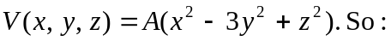
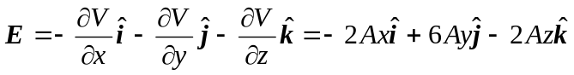

b) A charge is moved in along the -axis. So the work done is given by:
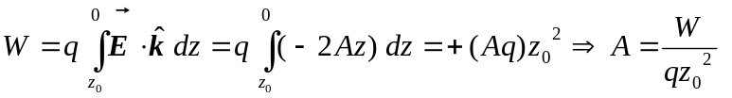
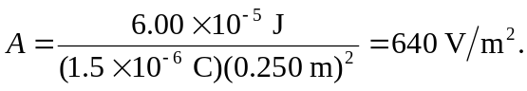
c)
d) In every plane parallel to the 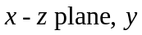 is constant, so:
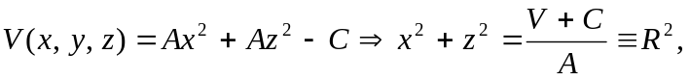
which is the equation for a circle since  is constant as long as we have constant potential on those planes.
e) 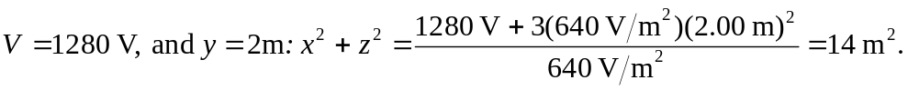 Thus the radius of the circle is 